***Operating system***

***Lab Work***

***Practical 1***

***Name :Shrey Vyas***

***Batch:F-1***

***Roll Number:22BCE335***

***1.UNIX System Organisation:***It is basically divided into the Hardware and the Software.The Hardware and the software meets at the kernel-controller interface.Basically,the Software is divided into two,System and Application Software.

On the top level,works the Application software with the user.It in turn works with the system software,I.e. OS(Operating System).The OS has within it the Kernel(the most basic unit of OS that deals with several things including the input and output control).We can safely say that while booting the OS into the Main Memory for the processor while turning on any device,within the OS it is the Kernel that gets loaded first.

The Kernel then works with the ugly part of the system(Hardware).There is a Kernel-Controller-Hardware communication that does the entire task.

This is the basic UNIX System Organisation.

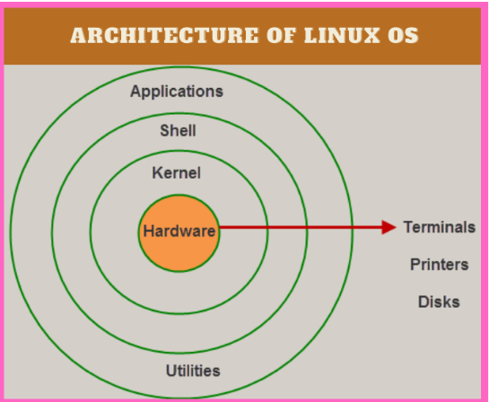

1. ***types of shells***

Shells expose the OS to the user to be manipulated.There are various types of shells.They are,Bash,zsh(Z shell),Korn Shell(ksh),Bourne Shell(bsh),tcsh,dash,ash,csh

***3.commands***

**1.who**

**Description:**Prints a list of all those users who are currently logged in.

**Output**

Not visible on online linux command line(Usually nirma and other computers connected to the server)

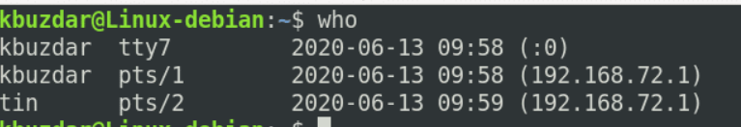

**2.who am i**

**Description:**Prints the effective user id.The id of our computer on the server.

**Output**

Not visible on online linux command line(Usually nirma).

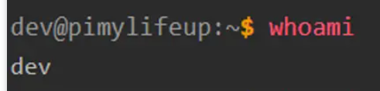

**3.touch**

**Description:**It changes the time stamps of the files.Basically,it creates a new file if not existing but the primary usage is to show that the file has been touched(accessed) recently according to the time stamps.

**Output**

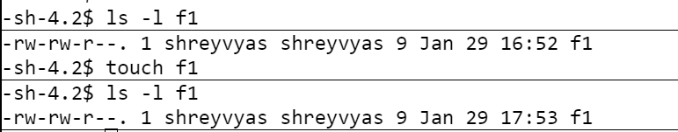

**4.cat**

**Description:**This command is used for writing,appending and reading from a file.If no parameter is passed,it takes the input from the filename specified and displays it on the monitor.

**Output**

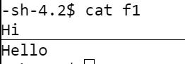

**5.cp**

**Description:**This is used to copy the contents of one file to another.It is done with the help of source and destination files.Relative and Absoloute addressing becomes a neccessity here.

**Output**

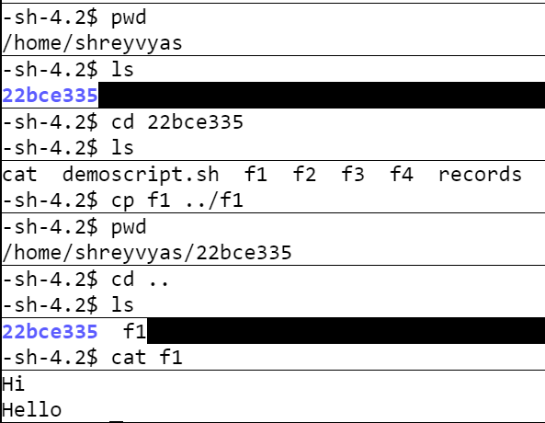

**6.rm**

**Description:**It is simply used to remove or delete a file.-d parameter can also remove empty directories.

**Output**

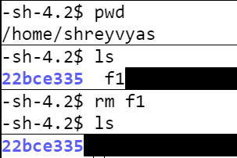

**7.mv**

**Description:**This is used to move a file or a directory from one address to the other.If the file is moved to the same directory,it gets renamed to the new file name.

**Output**

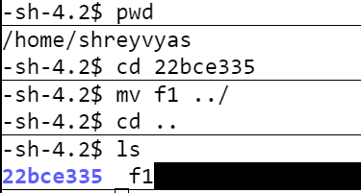

**8.ls**

**Description:**It gives us the list of all directories and files present in the present working directory.

**Output**

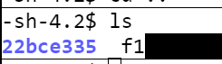

**9.ln**

**Description:**The ln command is a standard Unix command utility used to create a hard link or a symbolic link (symlink) to an existing file or directory. The use of a hard link allows multiple filenames to be associated with the same file since a hard link points to the inode of a given file, the data of which is stored on disk.

**Output**

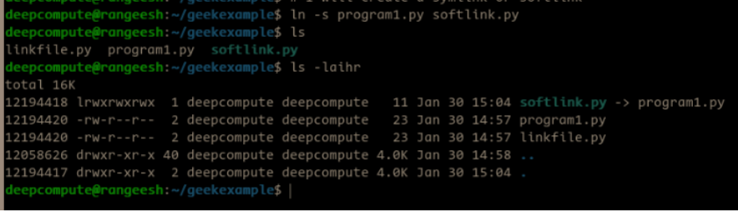

**10.chmod**

**Description:**There are read,write and execute permissions for each file and directory for each the user,the group and others.This permission can be changed with chmod command.

**Output**

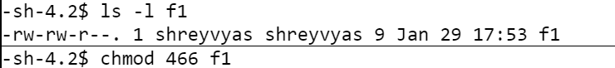

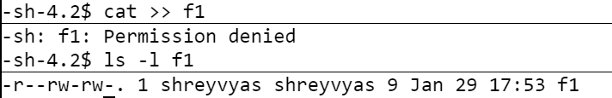

Read-4,write-2,execute-1(filetype-user-group-other)

**11.umask**

**Description:**It is used to check the default permissions when a directory or a file is created.It can be changed with the help of umask function.

**Output**



1. **pwd**

**Description:**It gives the absolute path of the directory that we are currently inside of or working in.(Present Working Directory)

**Output**



1. **mkdir**

**Description:**It is used to create a directory inside the pwd.

**Output**

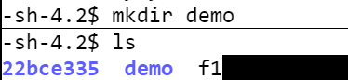

1. **rmdir**

**Description:**It is used to remove a directory within the pwd.However that directory has to be empty before deleting that directory.

**Output**

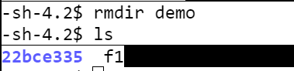

1. **cd**

**Description:**It is used to change the present working directory in command line of linux.

cd .. takes us to the parent directory.Otherwise,absolute and relative paths can be used.

**Output**

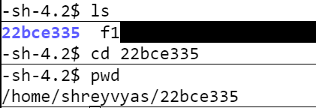

1. **bc**

**Description:**It stands for basic calculator.We can initialise variables,loops and other things just like a programming language,hence is the power of linux commands.

**Output**

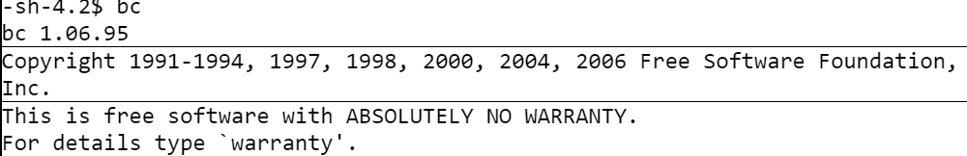

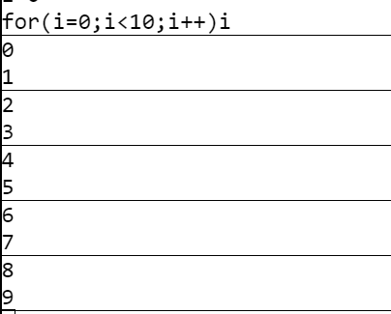

**17.bc -l**

**Description:**Define the standard math library.

**Output**

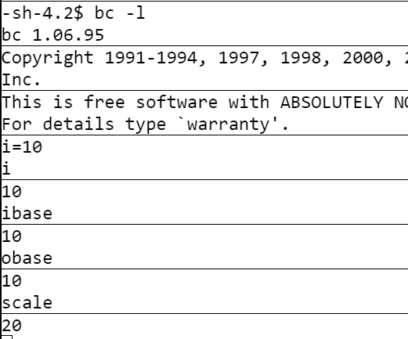

**18.expr**

**Description:**EIt is used to calculate an expression that is usually done in a calculator or in bc command

**Output**

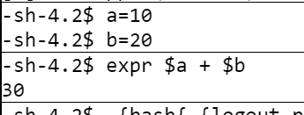

**19.factor**

**Description:**It is used to find the factors of any number in command line.

**Output**



**20.logname**

**Description:**EIt is used to print the users log in name.

**Output**



**21.uname**

**Description;**EIt is used to print the system information.-s for kernel name,-n for nodename,-p for processor info,-o for OS info.

**Output**

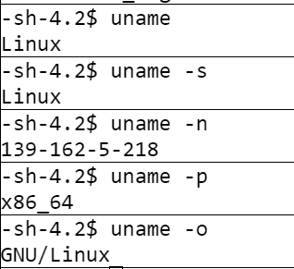

**22.tty**

**Description:**print the file name of the terminal connected to standard input.

**Output**

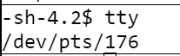

**23.date**

**Description:**Shows the complete information about the date and time.However,it has various uses such as displaying only the month,only the day,only the date and formatting them in the output.

**Output**

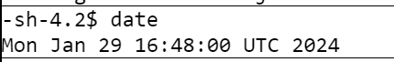

**24.df**

**Description:**It reports and prints the file system space usage.-l means only info about the local storage utilisation.

**Output**

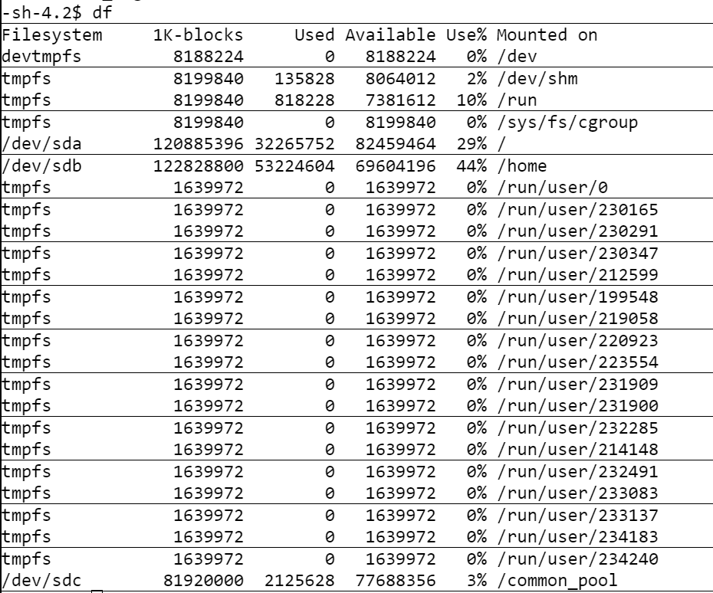

**25.du**

**Description:**It is used only to summarise the disk usage of each file.

**Output**

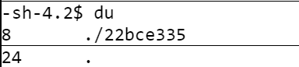

I have a directory called 22bce335 that has two files.

**26.ulimit**

**Description:**It is used to put an upper limit or upper bound on the system resources usage by the user.

**Output**



It means that 2048 kb maximum memory can be used at a time.

**27.cal**

**Description:**It prints the calender of the current month.

**Output**

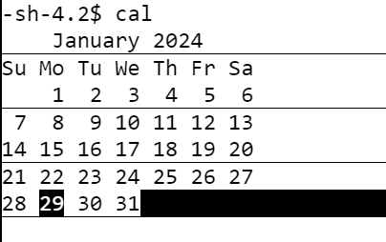

**28.wc**

**Description:**It prints the number of lines,words,and bytes in a file.

**Output**

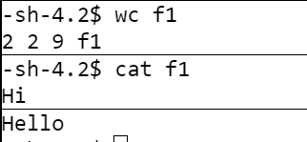

**28.sort**

**Description:**EIt is used to sort a given file in a particular order(either according to column or field or even by treating each character as a number and doing a numeric sort(sort -n f1))

**Output**

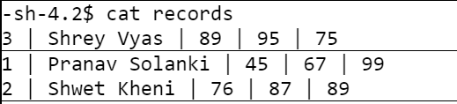

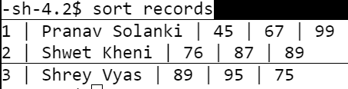

**29.cut**

**Description:**It is basically used to print that part of the table that we want,like a specific column or a specific field.

**Output**

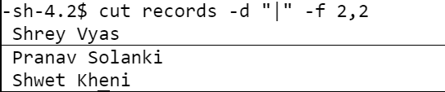

-d for delimiter and -f for mentioning the fields(Student name in this case).

1. **grep**

**Description:**It is like the where keywords in MySQl.We can use this command to search for certain records that meets a specific condition.

**Output**

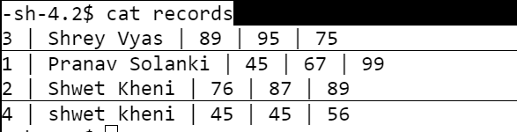

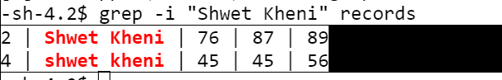

-i for insensitive case search

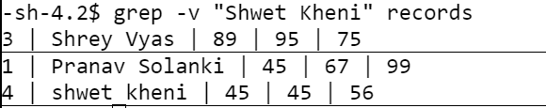

-v for giving the records not containg the search keyword.

**31.awk**

**Description:**The awk command programming language requires no compiling and allows the user to use variables, numeric functions, string functions, and logical operators.

**Output**

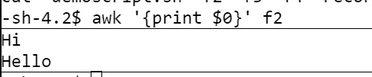

**32.head**

**Description:**It is used to print the records from the top of the file(lines).By default it prints the first 10 lines of the file.

**Output**

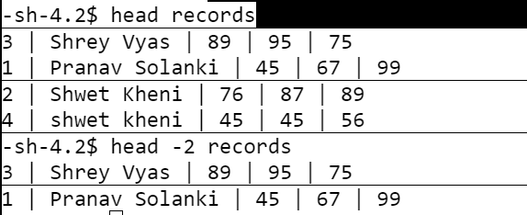

**33.pg**

**Description:**pg displays a text file, pausing after each "page" (the height of the [terminal](https://www.computerhope.com/jargon/t/terminal.htm) screen). After each page, a [prompt](https://www.computerhope.com/jargon/p/prompt.htm) is displayed. The user may then either press the [newline](https://www.computerhope.com/jargon/n/newline.htm) key to view the next page or one of the keys described below.

**Output**

pg myfile.txt

Displays the first screenful of the contents of text file myfile.txt, and a prompt (":"). Pressing the Return key displays the next page, or any of the command listed above may be entered to otherwise navigate the file.

Online Linux Command Line did not have pg command.

**34.more**

**Description:**The more command reads files and displays the text one screen at a time.It has got various options for viewing a file.

**Output**

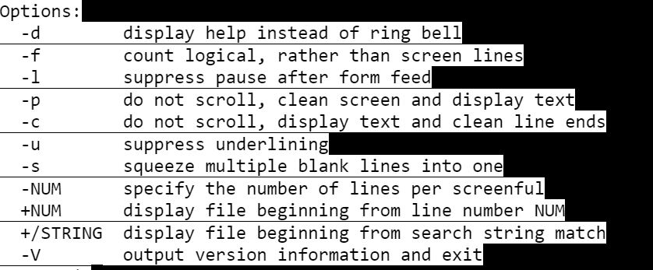

Upon more -p records,the screen automatically moves up and displays the file on a fresh screen.

**35.tail**

**Description:**This command is used to display the lines from the end of the file.By default it prints the last 10 lines of the file.

**Output**

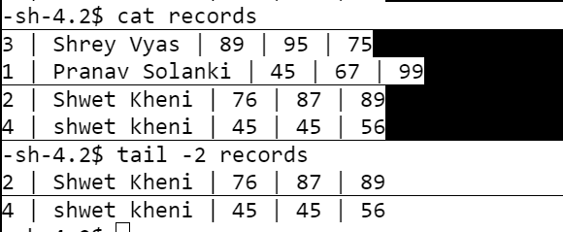

**36.pipe(|)**

**Description:**This is a symbol that is very important for IPC(Inter Process Communication),basically towards the left of this | is inputs and towards the right of this pipe is where the input is feeded.

**Output**

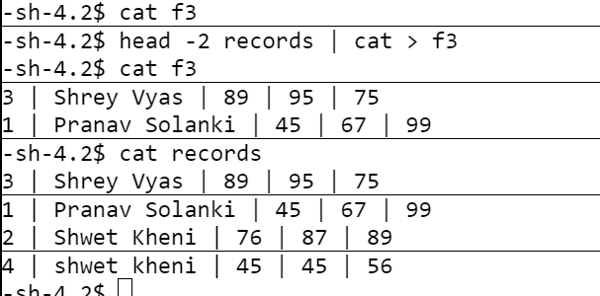

How the head can be used as input to the cat using | symbol.

**37.tee**

**Description:**It is a command that allows for one input and 2 sided output just like in a T.By default,one of the outputs gets redirected towards the screen.It can be used to both display and be saved in a file.

**Output**

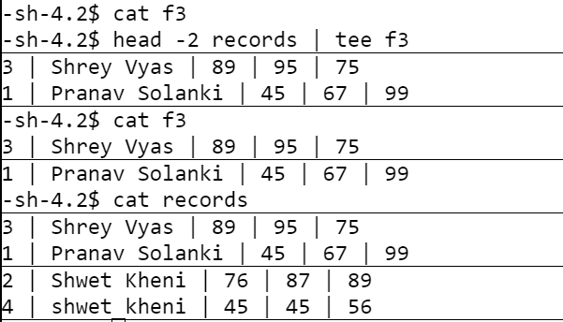

It gives the commands a dual advantage.

**38.ps**

**Description:**This command is used to give a snapshot of the current processes.

**Output**

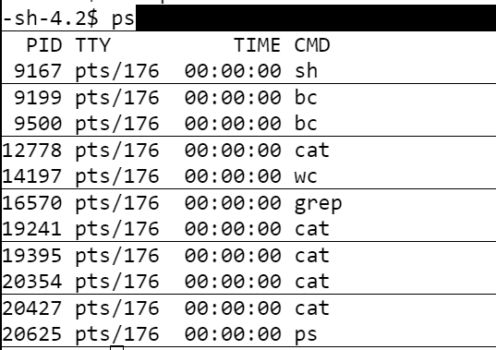

**39.kill**

**Description:** It is used to kill or terminate a process by using the command line.

**Output**

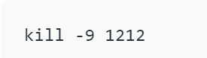

Sends the signal with id 9 to kill a process with id 1212

**40.nice**

**Description:**The Nice command is used to prioritize the execution of processes. It allows users to control the priority levels of processes, determining how much system resources a particular process should receive.

**Output:**Priorities are between -20(lowest) and 19(highest)We can set the priority of a command like this,

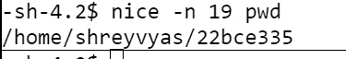

It sets the highest priority to the command pwd

**41.read**

**Description:**It is used to read a data(number string or file) from the user.

**Output**

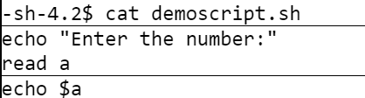

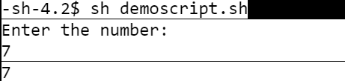

**42.echo**

**Description:**It is used to print a variable or data on the screen.

**Output**

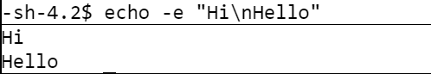

**43.I/O redirection**

**Description:**EIt is used to redirect the input and the output to specified files.By default,output is redirected towards the screen and input from the keyboard(handles both processes like files).

**Output**

